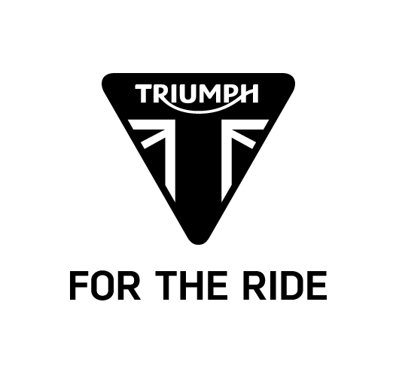

PRESS RELEASE

ALL NEW TRIUMPH SPEED TRIPLE MODELS UNVEILED.

- All new Speed Triple S and Speed Triple R
- NEW 1050cc triple engine with 104 new developments with increased torque throughout the rev range
- NEW rider-focused technology including riding modes, switchable ABS and switchable Traction Control
- NEW styling including all new twin headlamps and all new bodywork
- Significantly narrower engine/radiator package giving 20mm narrower stand-over
- Brembo monoblock calipers as standard across S and R models
- R features bellypan, carbon bodywork inserts and front mudguard, billet finishers and Öhlins suspension front and rear
- Four NEW colourways – Phantom Black and Diablo Red on the Speed Triple S, Crystal White and Matt Graphite on the Speed Triple R
- Designed to be true to the Speed Triple DNA - Delivering the perfect balance of performance, handling, capability and character

The NEW Triumph Speed Triple S and Speed Triple R take the legacy of the first factory street fighter to a completely new level in terms of performance, agility, power, handling and capability.

Centred around a new 1050cc triple engine, the new Speed Triple S and R redefine the naked performance roadster. The new engine features 104 new developments that combine to deliver more power and, more importantly, more torque across the whole rev range whilst still meeting Euro 4 regulations and delivering an increase of up to 10% fuel efficiency. These developments include a new combustion chamber, new cylinder head, a new machined crank, new piston design and new ‘Ride-by-Wire’ throttle bodies. Additional developments also include a slip assist clutch, smaller, more efficient radiator and a new free-flowing exhaust that has a 70% increase in flow rate.

The NEW Speed Triple S and Speed Triple R also feature a suite of rider-focused technology. Among the features that add to the Speed Triple’s performance and capability are a new ECU coupled to a new adjustable Ride-by-Wire throttle with selectable throttle maps that increase the feel, responsiveness and control. There are now 5 distinct riding modes to choose from: Road, Rain, Sport, Track and a new Rider Configurable mode, that all allows the rider to set-up the motorcycle to the optimum performance relative to road conditions or environment.

Key to the new Speed Triple S and R is the aggressive, athletic styling and a narrow, focused design. A low, lithe stance is accentuated by sleek new bodywork and a completely new, Daytona 675R-inspired, tailpiece. All of which has been achieved without losing any of the naked minimalist beauty that is synonymous with the Speed Triple.

The new Triumph Speed Triple S and Speed Triple R redefine the Speed Triple legend – delivering the perfect balance of power, handling, capability and character in two new performance roadsters designed for maximum fun and maximum thrills with maximum attitude.

Speed Triple S | Speed Triple R
Spec highlights include: | In addition to the Triple S spec:
- New triple engine with 104 new components  - Improved peak power and torque spread across entire rev range  - Ride-by-Wire throttle  - 5 Rider Modes including a Track Mode  - Rider-selectable ABS  - Rider-selectable traction control linked to Rider Modes  - Brembo monobloc front brake calipers  - Fully adjustable suspension, front and rear  - Redesigned, narrower radiator  - Restyled radiator shrouds, rear bodywork and silencers  - Choice of two distinctive colourways:  - Diablo Red  - Phantom Black | - Light weight high spec body panels:  - Carbon fibre front mudguard  - Carbon fibre fuel tank infill panels  - Higher specification, fully adjustable suspension:  - Öhlins NIX30 upside down front forks  - Öhlins TTX36 RSU  - High quality finishing details:  - Billet-machined handlebar clamps, risers, swingarm pivot covers and rear wheel finisher  - Choice of two bespoke paint schemes and detailing:  - Crystal White  - Matt Graphite  - Red painted sub-frame, wheel pinstripes, radiator cowls  - Red seat stitching detail

– ends –

For further information, please contact Nik Ellwood, Global PR Manager on 01455 453434 or email nik.ellwood@triumph.co.uk

Notes to Editors

About Triumph

- First established in 1902, Triumph Motorcycles celebrated 110 years of motorcycle manufacture in 2012. For more than two decades, Triumph Motorcycles has been based in Hinckley, Leicestershire, and has produced iconic bikes that perfectly blend authentic design, character, charisma and performance.

- The Triumph Bonneville, famously named to celebrate Triumphs 1956 land speed record on the Bonneville Salt Flats in Utah, USA. The original British superbike and a race winner straight out of the crate. Chosen by famous motorcyclists of the past for its legendary handling, style, and character. It’s that handling, character and style, married to modern rider technology that makes the new Bonneville family THE authentic modern classic
choice today.

- Building around 54,500 bikes per year, Triumph is the largest British motorcycle manufacturer and has over 750 dealers across the world.

- Triumph holds a unique place in the history of the International Six Day Trials as the motorcycle of choice for both the multiple winning British teams and famously Steve McQueen’s US ride entry in 1964.

- At the heart of Triumph’s philosophy is a commitment and passion to develop truly unique motorcycles that offer a blend of distinctive design, intuitive handling and performance to enjoy the perfect ride.

- This focus, innovation and engineering passion has today created a broad range of bikes suited to all motorcycle riders, including the striking 2.3 litre Rocket III, the unmistakable Speed Triple, the Daytona 200 and TT
winning SuperSports Daytona 675R, the class defining Tiger 800, the transcontinental Tiger Explorer and the iconic Triumph Bonneville family.

- Triumph currently employs around 2000 personnel worldwide and has subsidiary operations in the UK, America, France, Germany, Spain, Italy, Japan, Sweden, Benelux, Brazil, India, Indonesia and Thailand as well as
a network of independent distributors. Triumph has manufacturing facilities in Hinckley, Leicestershire, and Thailand plus CKD facilities
in Brazil and India.

